MEMBER VOTING PLATFORM
@CREATIVITY THINK (9483175986/7019689991)

ABSTRACT:
The Member Voting Platform is a web-based system designed to enable clubs, committees, and resident associations to conduct structured voting processes efficiently. The platform allows administrators to create polls, validate votes, and analyze results, while users can participate by viewing polls, casting votes, and accessing real-time results. With secure backend processing using Django and Django Rest Framework, and a responsive frontend built with React, Redux, and recharts, the system ensures transparency, accountability, and analytics-driven insights. This application provides an organized, secure, and scalable approach for online voting and poll management..

INTRODUCTION OF THE PROJECT:
Traditional voting and polling within organizations often involve manual processes, paper ballots, or unorganized digital methods that lack transparency and auditability. This results in inefficiencies, delayed results, and limited analytics. The Member Voting Platform addresses these challenges by providing a centralized, digital environment for creating polls, capturing votes, and generating dashboards. Users can securely participate in polls and monitor results, while administrators can manage voting activities, validate participation, and export reports. The system enhances accountability, engagement, and decision-making..

PROJECT OBJECTIVES:

• Enable administrators to create, manage, and monitor polls
• Allow users to view polls, cast votes, and track results
• Ensure secure and authenticated voting mechanisms
• Maintain detailed logs of votes and poll activity
• Provide dashboard analytics for both users and administrators
• Support data export for reporting and decision-making
• Offer a scalable and responsive web interface
• Reduce manual errors and increase transparency in voting

PROBLEM OF THE STATEMENT:
Manual and unstructured voting processes are prone to errors, lack transparency, and often delay results. Users cannot track participation effectively, and administrators lack actionable insights. The Member Voting Platform provides a structured, secure, and real-time solution where votes are accurately recorded, poll activity is monitored, and analytics are generated to guide organizational decision-making..

MOTIVATION OF THE PROJECT:
• To digitize the voting and polling process for clubs and associations
• To enhance transparency and accountability in voting
• To simplify poll creation and management for administrators
• To provide real-time insights and analytics on poll participation
• To enable secure, authenticated, and reliable voting
• To facilitate easy reporting and decision-making using exportable data
• To engage members efficiently with user-friendly interfaces

BLOCK DAIGRAM OF PROJECT:

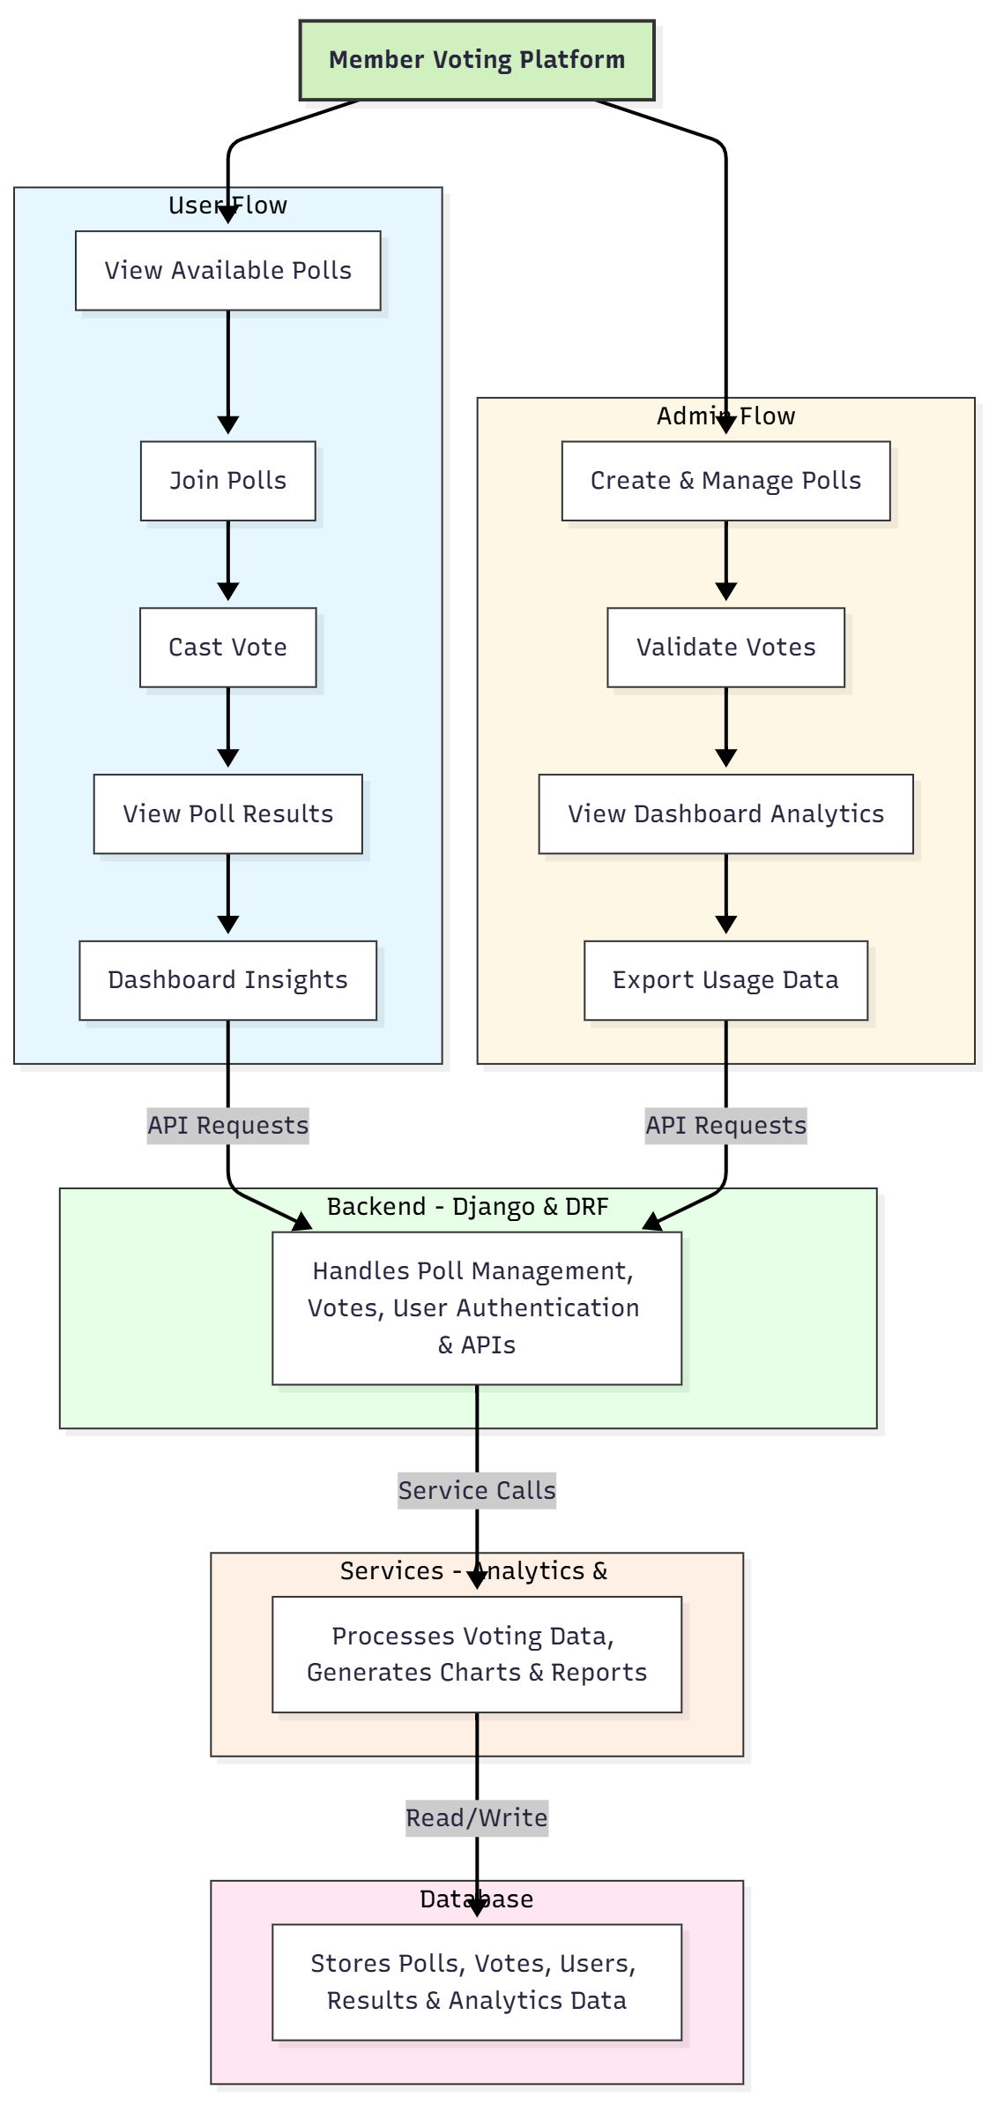

WORKING OF THE PROJECT:
The platform allows administrators to create polls with questions and options, set voting timelines, and manage participants. Users access the system to view available polls and submit votes securely. The backend records all votes, validates participation, and updates results in real-time. Users can view results immediately, while dashboards provide analytics on poll participation and voting patterns. Administrators can monitor overall activity, validate votes to prevent tampering, and export usage reports. The database maintains structured records of all polls, votes, and analytics for auditing and insights..

SOFTWARE REQUIREMENT:
- Backend:
  - Python 3.x
  - Django
  - Django REST Framework
  - SQLite/PostgreSQL
- Frontend:
  - Node.js and npm
  - React.js
  - Axios
- Development Tools:
  - Visual Studio Code
  - Postman (for testing APIs)
  - Git/GitHub (for version control)
- Server/Deployment (Optional):
  - Gunicorn, Nginx, or Heroku/AWS for hosting

ADVANTAGES OF THE PROJECT:

• Secure and reliable online voting platform
• Transparent poll creation and participation tracking
• Real-time results and analytics dashboards
• Ability to export reports for administrators
• Reduces manual paperwork and errors
• Engages members efficiently and improves participation
• Scalable for small and large associations
• Improves accountability and decision-making

APPLICATIONS OF THE PROJECT:
• Clubs and societies
• Resident associations and housing committees
• Committees within offices or institutions
• Student organizations and academic societies
• Community voting systems
• Decision-making boards and councils

REFERENCES:

- Django REST Framework Documentation — Django Software Foundation. Django Documentation. Available: https://docs.djangoproject.com/
- Django REST Framework. DRF Documentation. Available: https://www.django-rest-framework.org/
- React. React Official Documentation. Available: https://reactjs.org/docs/getting-started.html
- Redux. Redux Documentation. Available: https://redux.js.org/introduction/getting-started
- PostgreSQL Global Development Group. PostgreSQL Documentation. Available: https://www.postgresql.org/docs/
- MySQL. MySQL Reference Manual. Available: https://dev.mysql.com/doc/
- Git. Git Documentation. Available: https://git-scm.com/doc
- Node.js. Node.js Documentation. Available: https://nodejs.org/en/docs/
- Axios. Axios Documentation. Available: https://axios-http.com/docs/intro
- Socket.io Documentation – https://socket.io/docs/

